**What is Data Model?**

Example:

Lets say an E-Commerce website has diff. type of data.orders,customer,product,support etc. These data are arranged in a table and and are connected on basis of certain scenarios. This connection of different type of data forms a model.

**Definition:** A data model is an abstract model that organizes elements of data and

standardizes how they relate to one another and to the properties of real-world

entities.

,mhghgyftkfktyy

kjtkyukury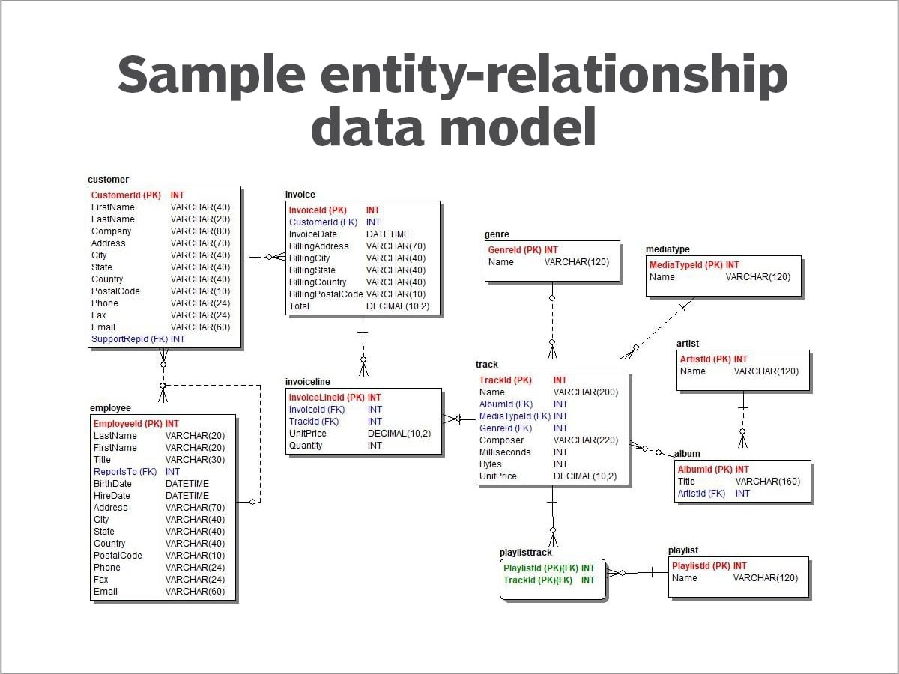

These are model in order to pull the required data which may depend on the details of other data.